**Cloud Computing Practical - 1**

**Aim**: To study cloud architecture and cloud computing model.

**Objectives**: From this experiment, the student will be able to

* provide an overview of concepts of Cloud Computing .
* To encourage students to indulge into research in Cloud Computing.

**Outcomes**: The learner will be able to

* understand and appreciate cloud architecture.
* analyze the local and global impact of computing on individuals, organizations, and society.
* recognize the need for, and an ability to engage in life-long learning.

**Hardware / Software Required**: Ubuntu operating system, Internet

**Theory:**

Cloud computing enables companies to consume compute resources as a utility -- just like electricity -- rather than having to build and maintain computing infrastructures in-house.Cloud computing promises several attractive benefits for businesses and end users.

**Three of the main benefits of cloud computing include:**

* Self-service provisioning: End users can spin up computing resources for almost any type of workload on-demand.
* Elasticity: Companies can scale up as computing needs increase and then scale down again as demands decrease.
* Pay per use: Computing resources are measured at a granular level, allowing users to pay only for the resources and workloads they use.

**Cloud computing services can be private, public or hybrid.**

Private cloud services are delivered from a business' data center to internal users. This model offers versatility and convenience, while preserving management, control and security. Internal customers may or may not be billed for services through IT chargeback.

In the public cloud model, a third-party provider delivers the cloud service over the Internet. Public cloud services are sold on-demand, typically by the minute or the hour. Customers only pay for the CPU cycles, storage or bandwidth they consume. Leading public cloud providers include Amazon Web Services (AWS), Microsoft Azure, IBM/SoftLayer and Google Compute Engine.

**Type of cloud computing:**

There are 3 main types of as-a-Service solutions: IaaS, PaaS, and SaaS. Each facilitates the flow of user data from front-end clients through the internet, to the cloud service provider’s systems, and back—but vary by what’s provided.

**Infrastructure as a Service (IaaS):**

[IaaS](https://www.redhat.com/en/topics/cloud-computing/what-is-iaas) means a cloud service provider manages the infrastructure for you—the actual servers, network, virtualization, and [data storage](https://www.redhat.com/en/topics/data-storage)—through an internet connection. The user has access through an API or dashboard, and essentially rents the infrastructure. The user manages things like the operating system, apps, and [middleware](https://www.redhat.com/en/topics/middleware) while the provider takes care of any hardware, networking, hard drives, data storage, and servers; and has the responsibility of taking care of outages, repairs, and hardware issues. This is the typical deployment model of [cloud storage](https://www.redhat.com/en/topics/data-storage/what-is-cloud-storage) providers.

**Platform as a Service (PaaS):**

[PaaS](https://www.redhat.com/en/topics/cloud-computing/what-is-paas) means the hardware and an application-software platform are provided and managed by an outside cloud service provider, but the user handles the apps running on top of the platform and the data the app relies on. Primarily for developers and programmers, PaaS gives users a shared cloud platform for application development and management (an important [DevOps](https://www.redhat.com/en/topics/devops) component) without having to build and maintain the infrastructure usually associated with the process.

**Software as a Service (SaaS):**

[SaaS](https://www.redhat.com/en/topics/cloud-computing/what-is-saas) is a service that delivers a software application—which the cloud service provider manages—to its users. Typically, SaaS apps are web applications or [mobile apps](https://www.redhat.com/en/topics/mobile) that users can access via a web browser. Software updates, bug fixes, and other general software maintenance are taken care of for the user, and they connect to the cloud applications via a dashboard or API. SaaS also eliminates the need to have an app installed locally on each individual user’s computer, allowing greater methods of group or team access to the software.

**Advantages and Disadvantages of cloud computing:**

**Advantages:**

Cloud Computing is an emerging technology that almost every company is being switched to from its on-premise technologies.

* Cost efficiency: The biggest reason behind companies shifting to Cloud Computing is that it takes considerably less cost than any on-premise technology. Now, companies need not store data in disks anymore as the cloud offers enormous storage space, saving money and resources.
* High speed: Cloud Computing lets us deploy the service quickly in fewer clicks. This quick deployment lets us get the resources required for our system within minutes.

**Disadvantages:**

Every technology has both positive and negative aspects that are highly important to be discussed before implementing it.

* No Redundancy: A cloud server is not redundant or backed up. Although it is an extra expense, make sure to invest in a redundancy plan as in most cases, it will be well worth it. Technology does sometimes seem to fail.
* Bandwidth issues: For better performance, it is advisable not to pack large numbers of storage devices and servers into a small set of data centers. The additional charges could be, however, significantly costly

**Conclusion**:

Cloud computing enables a convenient and on-demand

network access to a wide range of resources. The different services and also the deployment models allow flexible service provider interaction with minimal human intervention. It saves costs but also can lead to risk issues and suspension of resources when in huge quantities.

**Cloud Computing Practical - 2**

**Aim**: Installation and Configuration of virtualization using KVM.

**Objectives**: From this experiment, the student will be able to,

* Understand the concepts of virtualization.
* Understand KVM architecture and its configuration.

**Outcomes**: The learner will be able,

* To analyze user models and develop user centric interfaces
* To analyze the local and global impact of computing on individuals, organizations, and society.
* To engage in life-long learning development and higher studies.
* To understand, identify, analyze and design the problem, implement and
* validate the solution including both hardware and software.

**Hardware / Software Required:** Ubuntu operating system, open source software

KVM, Internet.

**Theory:**

Virtualization is software that separates physical infrastructures to create

various dedicated resources. It is the fundamental technology that powers

cloud computing.

The technology behind virtualization is known as a virtual machine monitor

(VMM) or virtual manager, which separates compute environments from the

actual physical infrastructure.

Virtualization makes servers, workstations, storage and other systems

independent of the physical hardware layer. This is done by installing a

Hypervisor on top of the hardware layer, where the systems are then installed.

**There are three areas of IT where virtualization is making headboards, network**

**virtualization, storage virtualization and server virtualization**:

**• Network virtualization** is a method of combining the available

resources in a network by splitting up the available bandwidth into channels,

each of which is independent from the others, and each of which can be

assigned (or reassigned) to a particular server or device in real time. The idea

is that virtualization disguises the true complexity of the network by

separating it into manageable parts, much like your partitioned hard drive

makes it easier to manage your files.

• **Storage virtualization** is the pooling of physical storage from multiple

network storage devices into what appears to be a single storage device that is

managed from a central console. Storage virtualization is commonly used in

storage area networks (SANs).

• **Server virtualization** is the masking of server resources (including the

number and identity of individual physical servers, processors, and operating

systems) from server users. The intention is to spare the user from having to

understand and manage complicated details of server resources while

increasing resource sharing and utilization and maintaining the capacity to

expand later.

Virtualization can be viewed as part of an overall trend in enterprise IT that

includes autonomic computing, a scenario in which the IT environment will be

able to manage itself based on perceived activity, and utility computing, in

which computer processing power is seen as a utility that clients can pay for

only as needed. The usual goal of virtualization is to centralize administrative

tasks while improving scalability and work loads.

**Procedure**:

**Installation Steps** :

1. #sudo grep -c "svm\|vmx" /proc/cpuinfo

2. #sudo apt-get install qemu-kvm libvirt-bin bridge-utils virt-manager

3. #sudoadduserrait

#sudoadduserraitlibvirtd

After running this command, log out and log back in as rait

4. Run following command after logging back in as rait and you should see an

empty list of virtual machines. This indicates that everything is working correctly.

#virsh -c qemu:///system list

5. Open Virtual Machine Manager application and Create Virtual Machine

#virt-manager

**Result:**

**Step 1 : #sudo grep -c "svm\|vmx" /proc/cpuinfo**

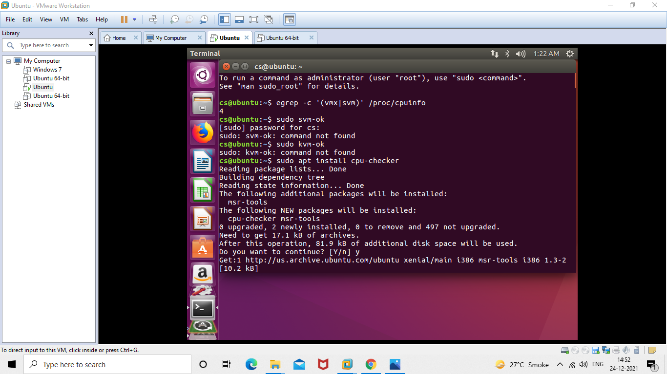

**Step 2 : #sudo apt-get install qemu-kvm libvirt-bin bridge-utils virt-manager**

**Step 3 : #sudoadduserrait**

**After running this command, log out and log back in as rait**

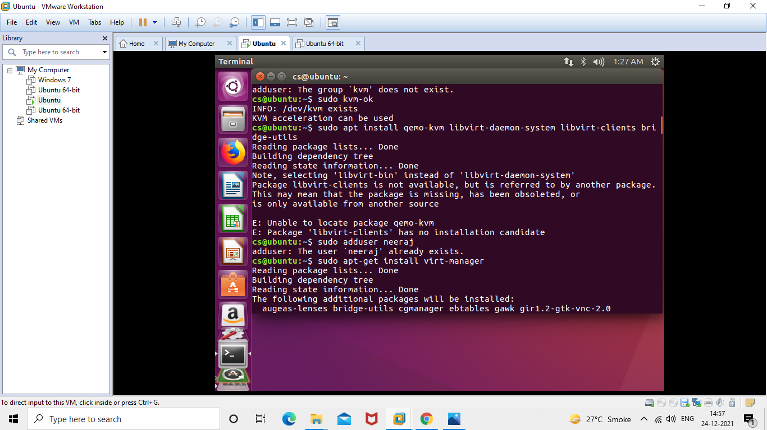

**Step 4 : #sudoadduserraitlibvirtd**

**After running this command, log out and log back in as rait**

**Step 5 : Open Virtual Machine Manager application and Create Virtual Machine**

**#virt-manager as shown below**

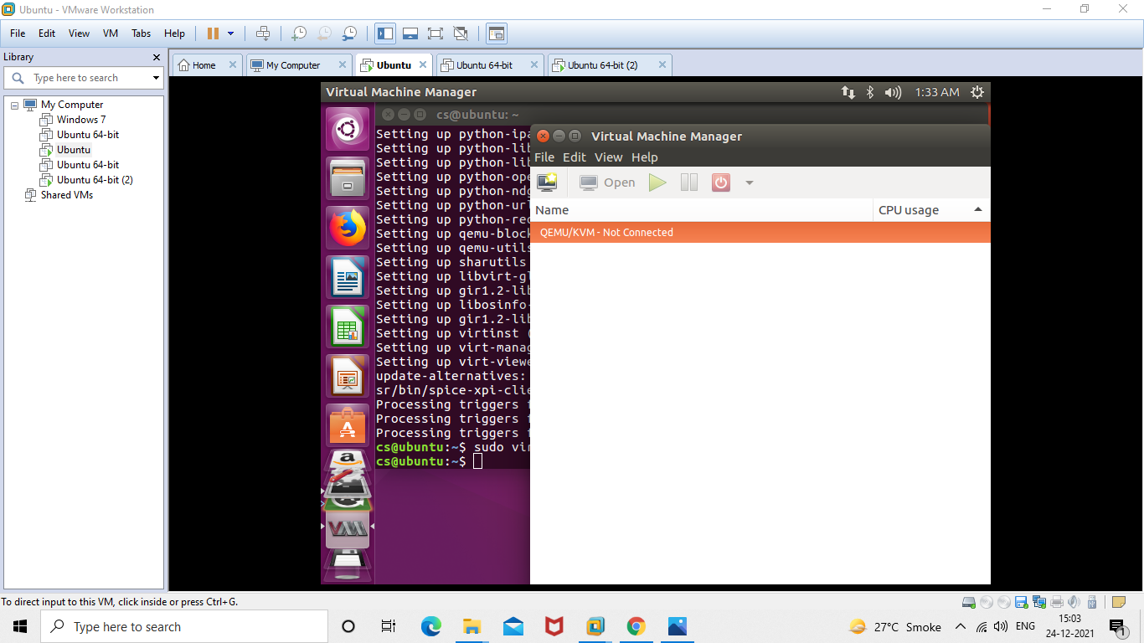

**Step 6 : Create a new virtual machine as shown below**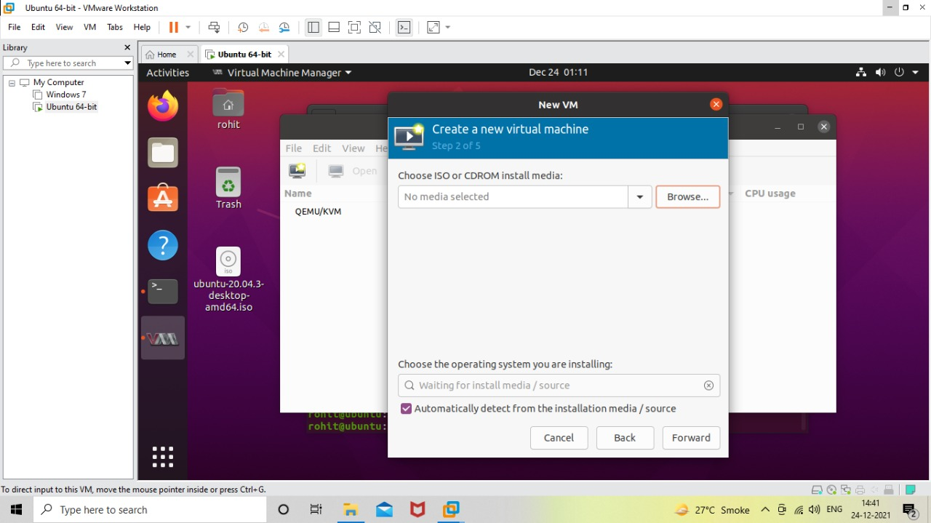

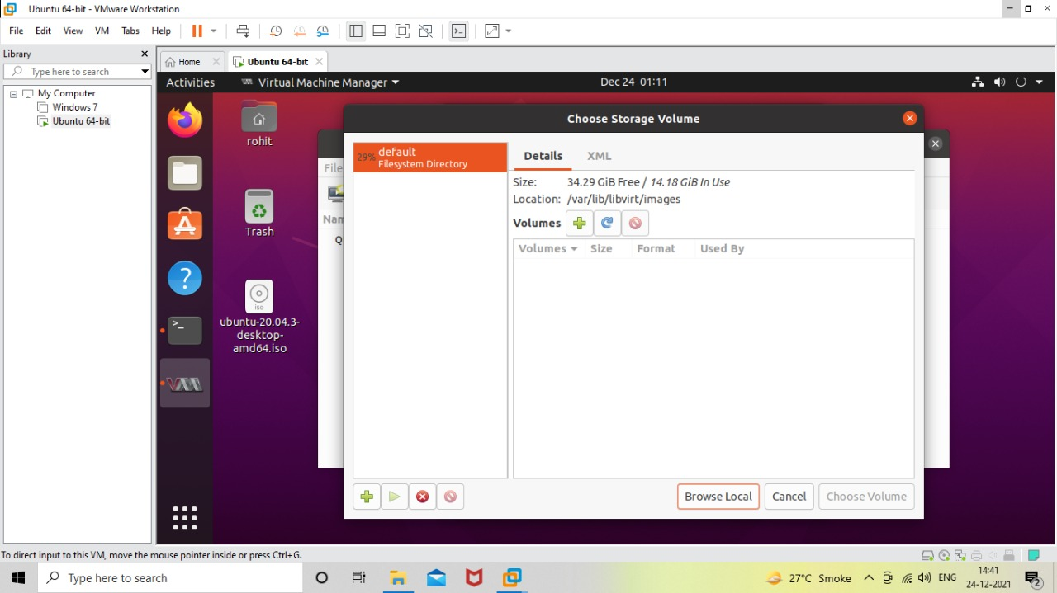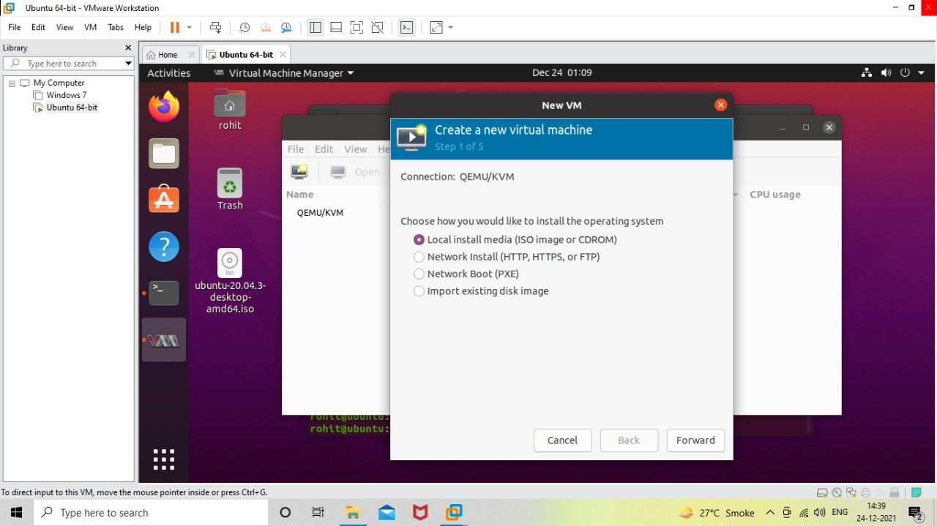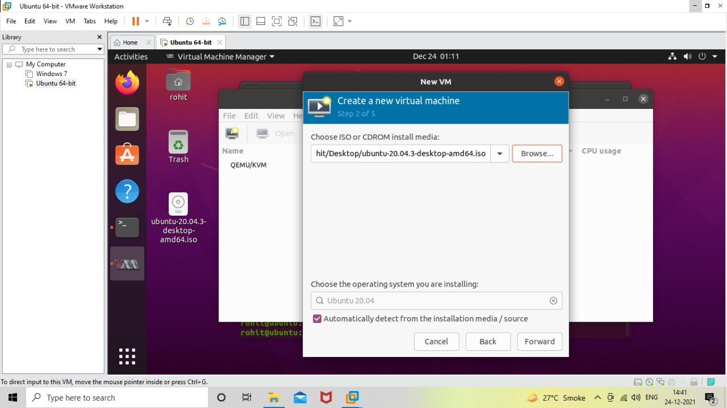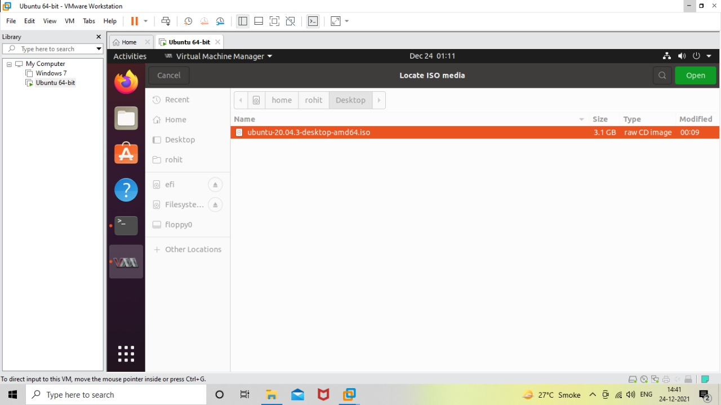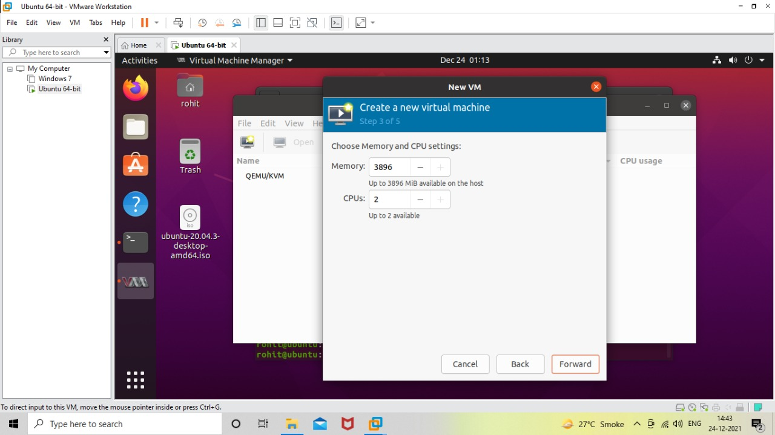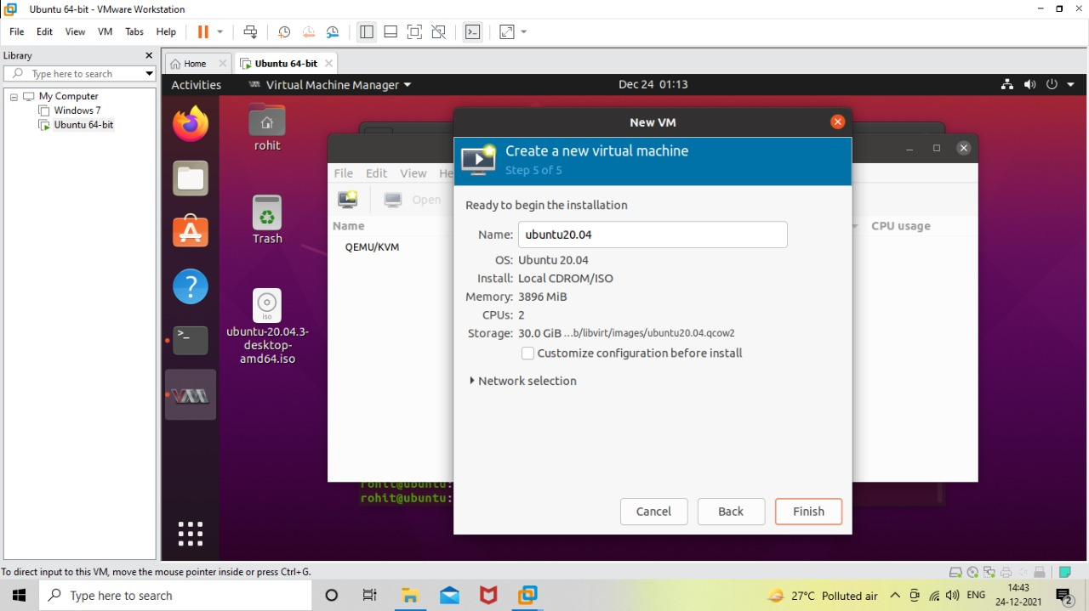

**Step 7 : Install windows operating system on virtual machine**

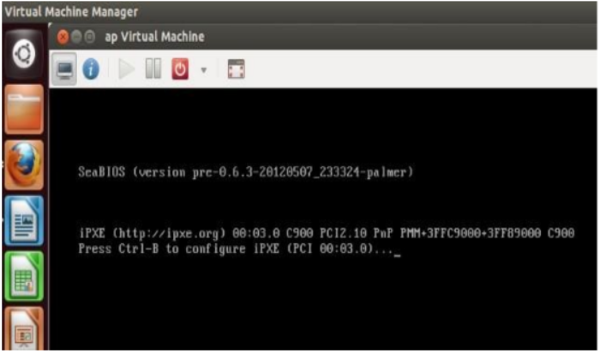

**Step 8: Installation of windows 7 on virtual machine**

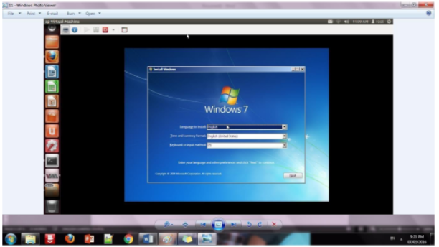

**Conclusion:**

Installation and configuration of KVM have been done successfully onto Ubuntu and

users added. Like this we can create as many virtual machines as possible on OS and

can install any windows onto it.

**Cloud Computing Practical - 3**

**Aim**: To study and implementation of Infrastructure as a Service

**Objectives**: From this experiment, the student will be able to,

* Understand concepts of virtualization and to use cloud as Infrastructure as a
* services.
* Learn the technique and its complexity
* Understand the importance of this technique from application point of view

**Outcomes**: The learner will be able,

* To match the industry requirements in the domains of Database management,
* Programming and Networking with limited infrastructure.
* To analyze the local and global impact of computing on individuals,
* organizations, and society.
* To use current techniques, skills, and tools necessary for computing practice.

**Hardware / Software Required**: Ubuntu operating system, Virtual machine, WAMP/XAMPP server, Any tool or technology can be used for implementation of web application e.g., JAVA, PHP, etc.

**Theory**:

**Infrastructure as a Service (IaaS):**

[IaaS](https://www.redhat.com/en/topics/cloud-computing/what-is-iaas) means a cloud service provider manages the infrastructure for you—the actual servers, network, virtualization, and [data storage](https://www.redhat.com/en/topics/data-storage)—through an internet connection. The user has access through an API or dashboard, and essentially rents the infrastructure. The user manages things like the operating system, apps, and [middleware](https://www.redhat.com/en/topics/middleware) while the provider takes care of any hardware, networking, hard drives, data storage, and servers; and has the responsibility of taking care of outages, repairs, and hardware issues. This is the typical deployment model of [cloud storage](https://www.redhat.com/en/topics/data-storage/what-is-cloud-storage) providers.

**Procedure:**

**Installation Steps:**

**Add user**

* useradd -s /bin/bash -d /opt/stack -m stack
* apt-get install sudo -y
* echo "stack ALL=(ALL) NOPASSWD: ALL" >> /etc/sudoers
* login as stack user

**Download DevStack**

* sudo apt-get install git -y || sudo yum install -y git
* git clone https://git.openstack.org/openstack-dev/devstack
* cd devstack

**Run DevStack**

Now to configure stack.sh. DevStack includes a sample **devstack/samples/local.conf**.

Create local.conf as shown below to do the following:

* Set FLOATING_RANGE to a range not used on the local network, i.e.

192.168.1.224/27. This configures IP addresses ending in 225-254 to be used as

floating IPs.

* Set FIXED_RANGE and FIXED_NETWORK_SIZE to configure the internal

address space used by the instances.

* Set FLAT_INTERFACE to the Ethernet interface that connects the host to your

local network. This is the interface that should be configured with the static IP address mentioned above.

* Set the administrative password. This password is used for

the admin and demo accounts set up as OpenStack users.

* Set the MySQL administrative password. The default here is a random hex string

which is inconvenient if you need to look at the database directly for anything.

* Set the RabbitMQ password.
* Set the service password. This is used by the OpenStack services (Nova, Glance, etc) to authenticate with Keystone.

**local.conf** should look something like this:

[[local|localrc]]

FLOATING_RANGE=192.168.1.224/27

FIXED_RANGE=10.11.12.0/24

FIXED_NETWORK_SIZE=256

FLAT_INTERFACE=eth0

ADMIN_PASSWORD=supersecret

DATABASE_PASSWORD=iheartdatabases

RABBIT_PASSWORD=flopsymopsy

SERVICE_PASSWORD=iheartksl

**Run DevStack:**

./stack.sh

A seemingly endless stream of activity ensues. When complete you will see a summary

of stack.sh’s work, including the relevant URLs, accounts and passwords to poke at your shiny new OpenStack.

**Using OpenStack**

At this point you should be able to access the dashboard from other computers on the local network. In this example that would be http://192.168.43.29/ for the dashboard (aka Horizon). Launch VMs and if you give them floating IPs and security group access those VMs will be accessible from other machines on your network.

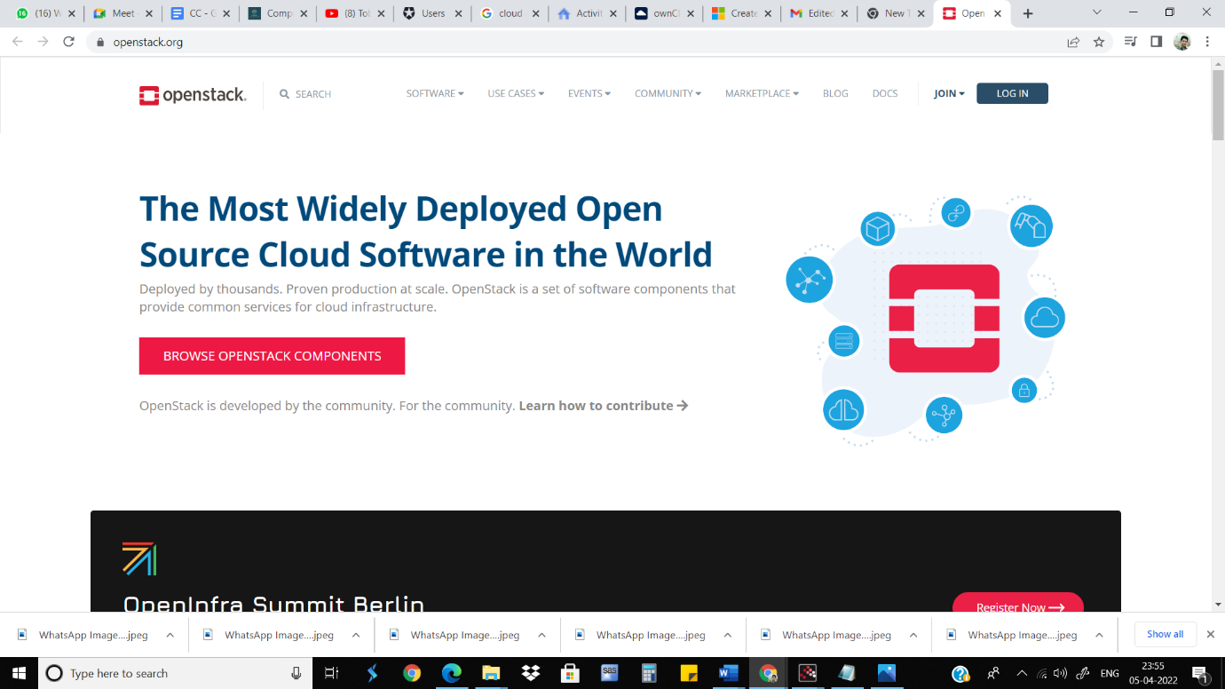

**IAAS using google cloud platform:**

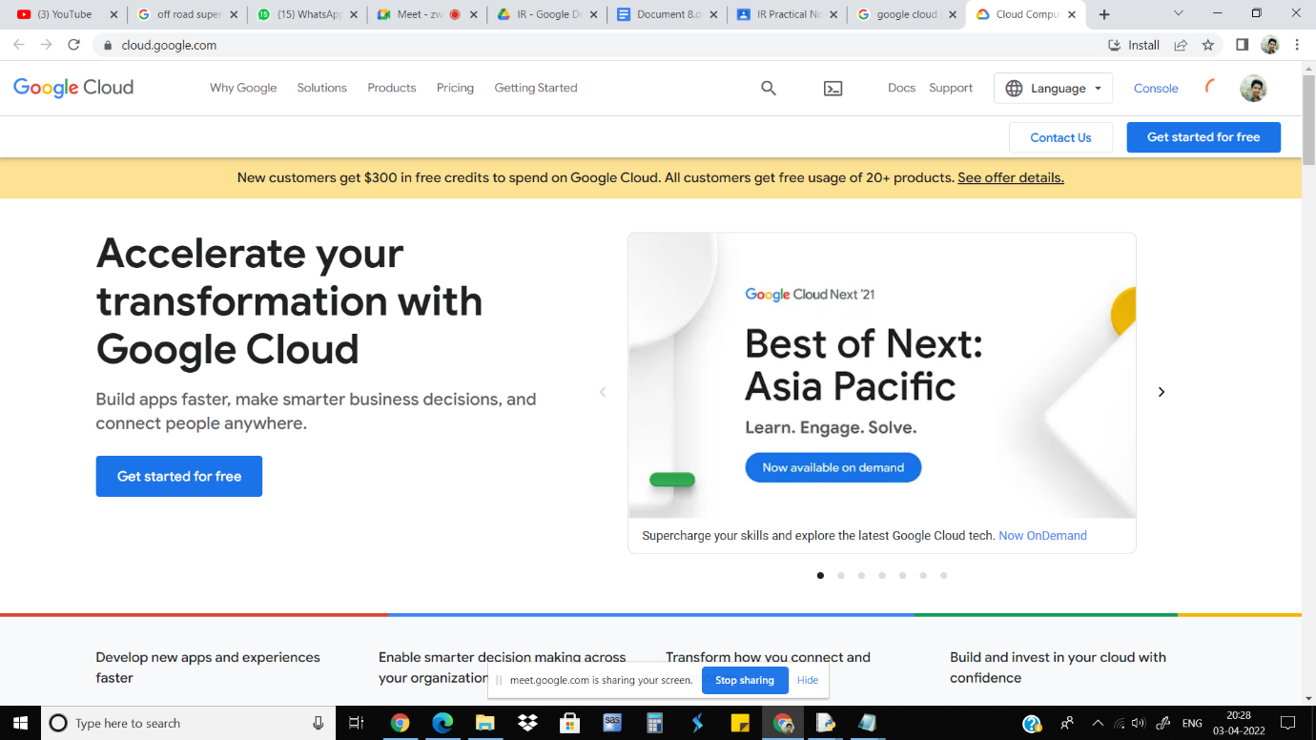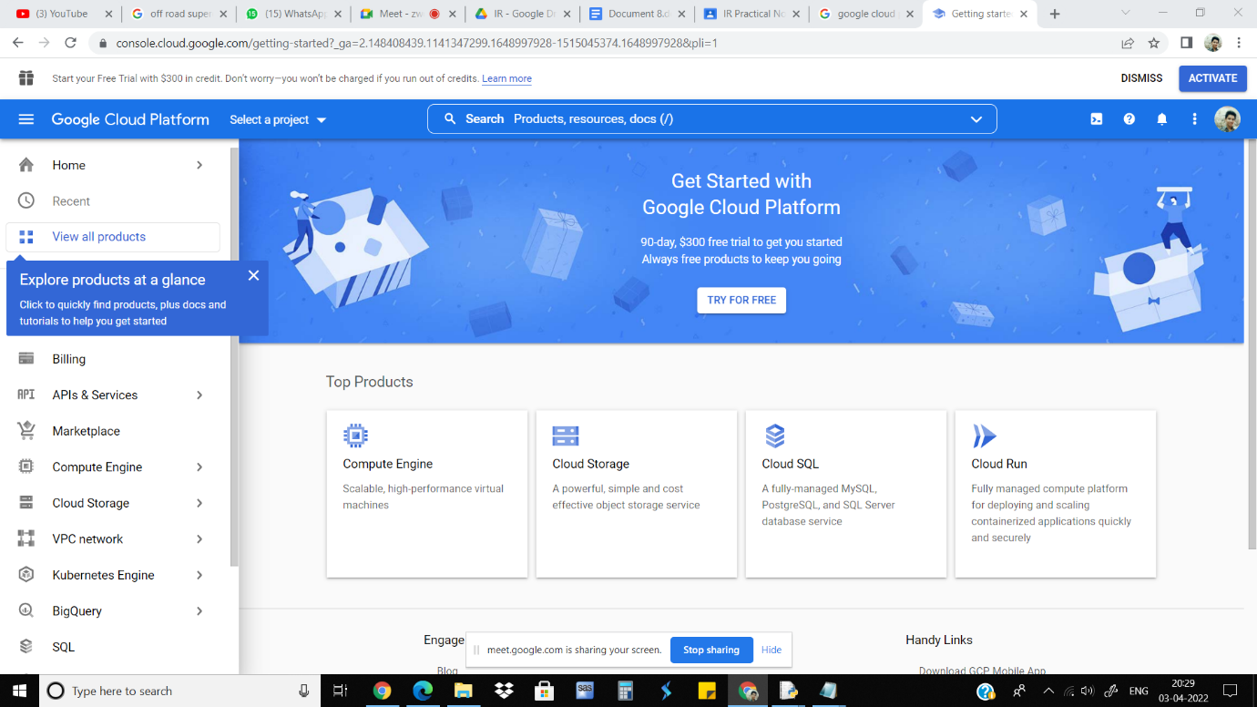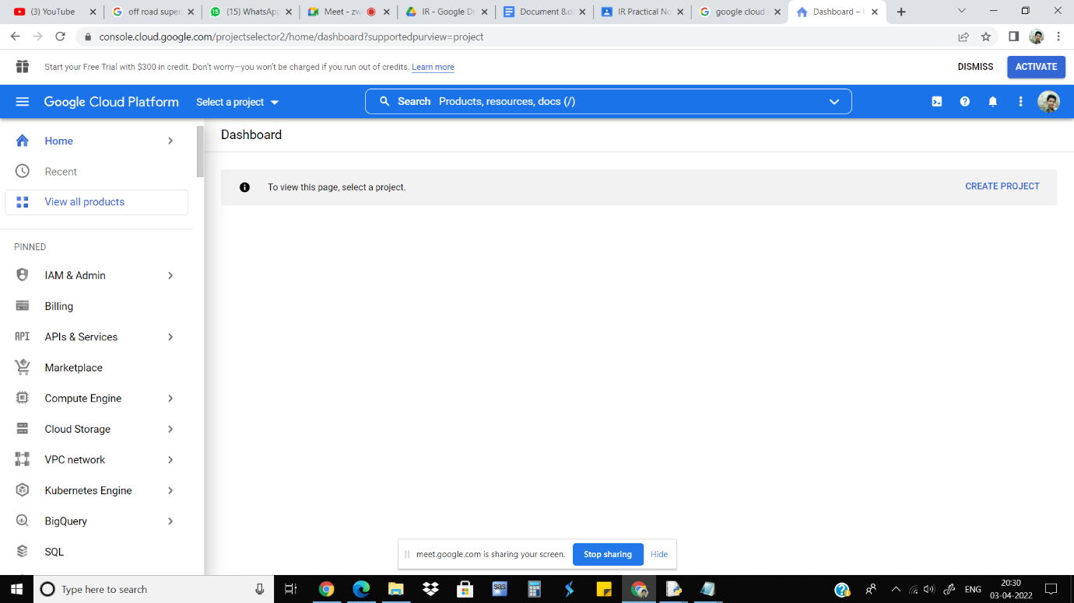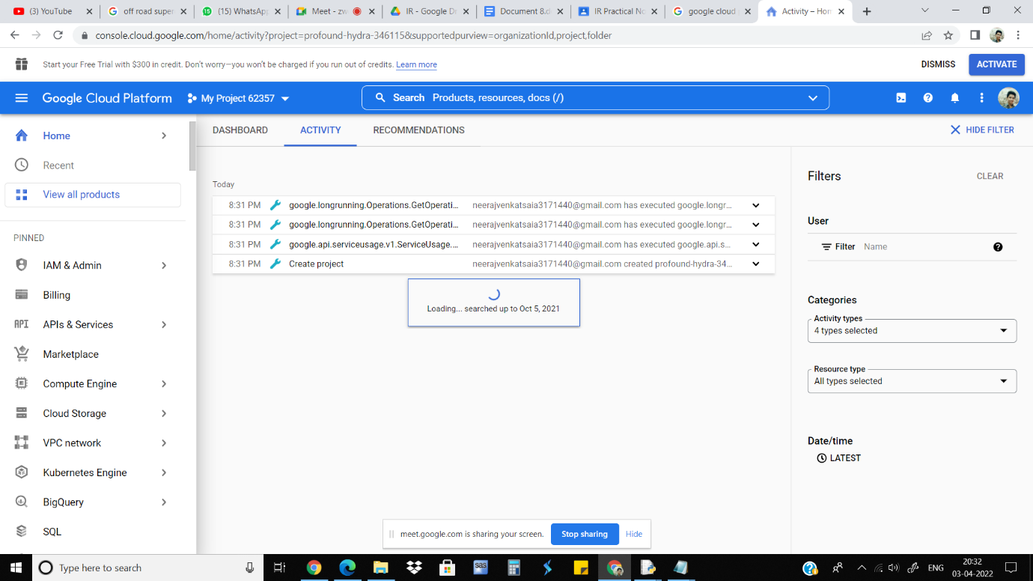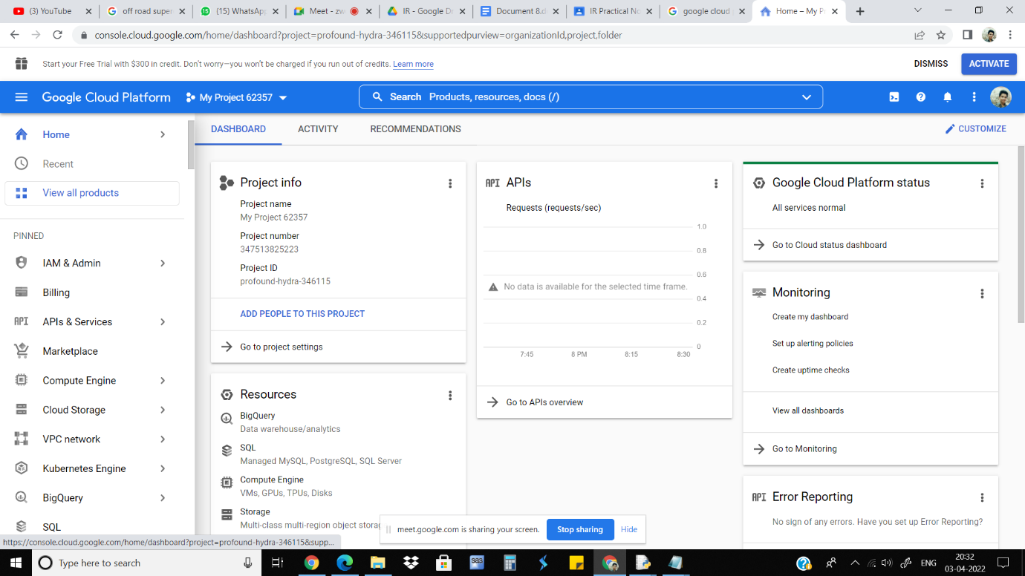

**Conclusion:**

We have installed Ubuntu/Xen as a bare metal hypervisor and implemented it. It

provides access to computing resources in a virtual environment. With the

with the help of Infrastructure as a service we can build our own IT platform. We can

install Windows Operating System on Ubuntu and vice versa.

**Cloud Computing Practical - 4**

**Aim**: To study and implementation of Storage as a Service

**Objectives**: From this experiment, the student will be able to

* To make the students understand the use of cloud as Platform, Storage as services.
* To learn the efficient tools to implement the technique

**Outcomes**: The learner will be able to

* To create and use online infrastructure.
* To analyze the local and global impact of computing on individuals,
* organizations, and society.

**Hardware / Software Required:**Windows operating system, Gmail account, Google drive.

**Theory:**

**Storage as a service (STaaS)** is a data storage business model where a provider rents storage resources to a customer through a subscription. STaaS saves you money through operating expenditure (OpEx) agility—you only pay for the storage you need, when you need it.

Buying new storage capacity can be an expensive capital expenditure (CapEx), especially if you aren’t sure how much capacity you’ll need in the future. You can try to predict the growth of your business and purchase with the future in mind, but it can tie up financial resources that might have more impact elsewhere in your business.

**Benefits of STaaS:**

* Ability to quickly scale and provision storage resources to your apps as you grow
* Always-on reliability of major cloud service providers
* Simplified storage management environment

**Result: Using Google Drive**

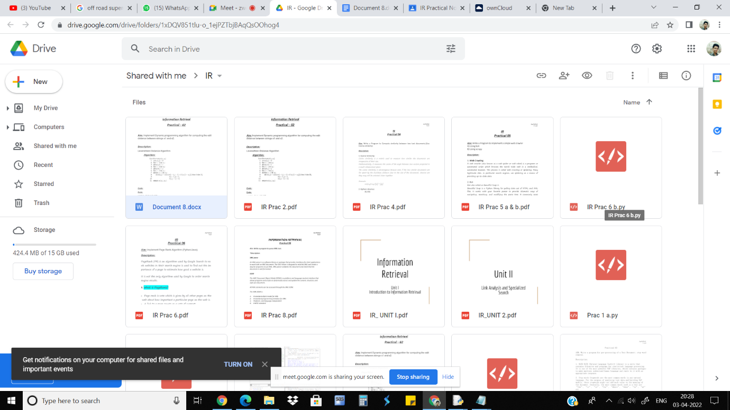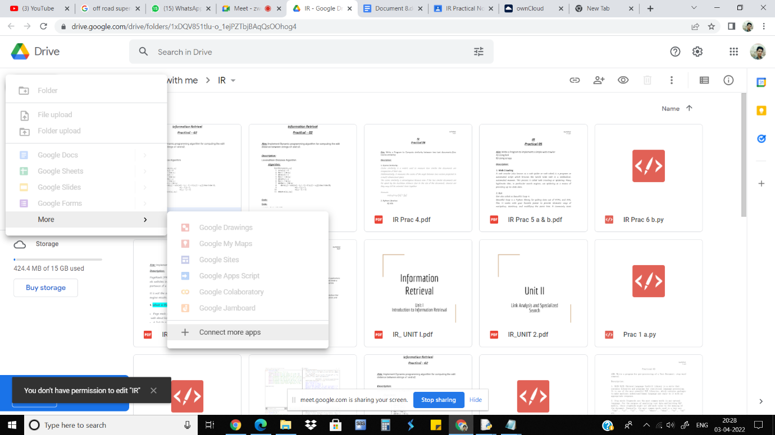

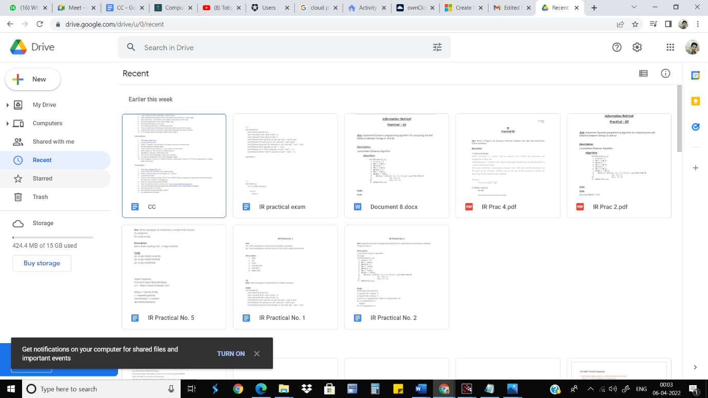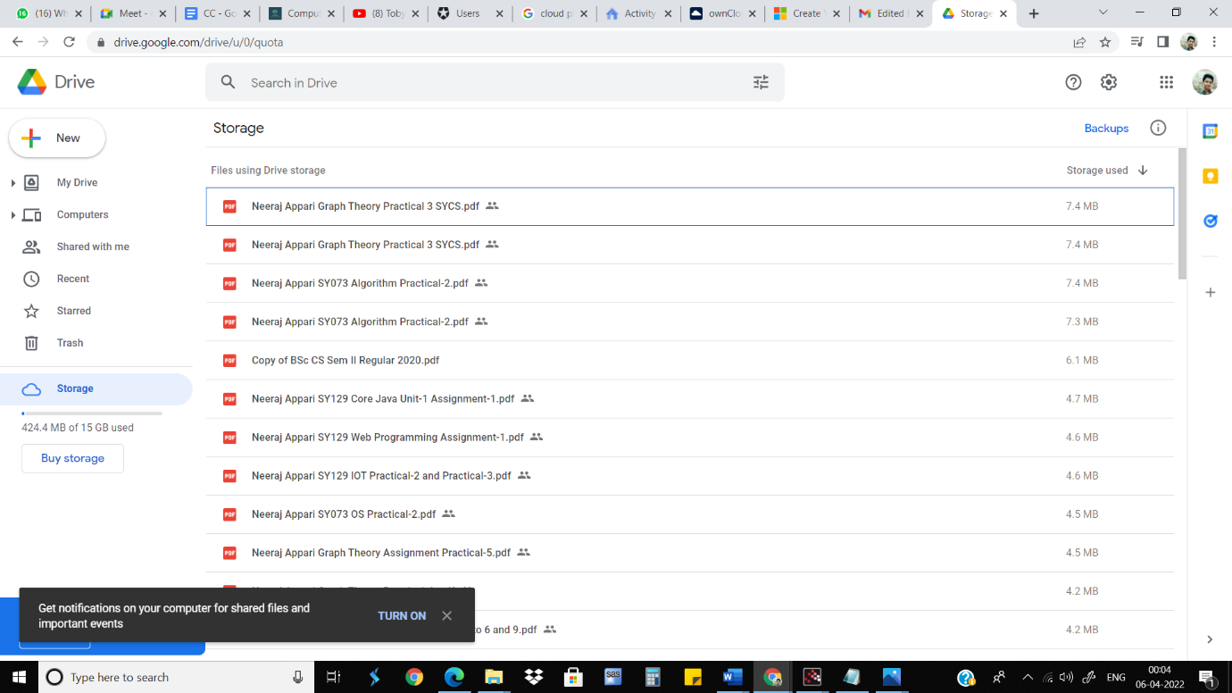

**Conclusion:**

Google Docs provide an efficient way for storage of data. It fits well in Storage as a service (SaaS). It has varied options to create documents, presentations and also spreadsheets. It saves documents automatically after a few seconds and can be shared anywhere on the Internet at the click of a button.

**Cloud Computing Practical - 5**

**Aim**: To study and implementation of identity management

**Objectives:** From this experiment, the student will be able to,

* Understand concepts of virtualization and to use cloud as Infrastructure as a service.
* Learn the technique and its complexity.
* Understand the importance of this technique from an application point of view.

**Outcomes**: The learner will be able to

* To create and use online identity.
* To analyze the local and global impact of computing on individuals,

organizations, and society and users of the company how to share and connect with each other.

**Hardware / Software Required:**Windows operating system, Gmail account, owncloud credentials

**Theory:**

The primary goal of identity management in cloud computing is dealing with personal identity information so that a user’s access to data, computer resources, applications, and services is controlled accurately.

Identity management in cloud computing is the subsequent step of identity and access management (IAM) solutions. However, it is a lot more than merely a straightforward web app single sign-on (SSO) solution. This next generation of IAM solution is a holistic move of the identity provider right to the cloud. Known as Directory-as-a-Service (DaaS), this particular service is the advanced version of the conventional and on-premises solutions, including Lightweight Directory Access Protocol (LDAP) as well as Microsoft Active Directory (AD).

ownCloud is an open source file sync and share software for everyone from individuals operating the free ownCloud Server edition, to large enterprises and service providers operating the ownCloud Enterprise Subscription. ownCloud provides a safe, secure, and compliant file synchronization and sharing solution on servers that you control.

**Result:**

**Steps: 1.**

By default, the ownCloud Web interface opens to your Files page. You can add,

remove, and share files, and make changes based on the access privileges set by you (if you are administering the server) or by your server administrator. You can access your ownCloud files with the ownCloud web interface and create, preview, edit, delete, share, and re-share files. Your ownCloud administrator has the option to disable these features, so if any of them are missing on your system ask your server administrator.

**2.**

Apps Selection Menu: Located in the upper left corner, click the arrow to open a

dropdown menu to navigate to your various available apps. Apps Information field: Located in the left sidebar, this provides filters and tasks associated with your selected app. Application View: The main central field in the ownCloud user interface. This field displays the contents or user features of your selected app.

**3.**

Share the file or folder with a group or other users, and create public shares with

hyperlinks. You can also see who you have shared with already, and revoke shares by clicking the trash can icon. If username auto-completion is enabled, when you start typing the user or group name ownCloud will automatically complete it for you. If your administrator has enabled email notifications, you can send an email notification of the new share from the sharing screen.

**4.**

Five Share permissions are :

Can share; allows the users you share with to re-share.

Can edit; allows the users you share with to edit your shared files, and to collaborate using the Documents app.

Create; allows the users you share with to create new files and add them to the share.

Change; allows uploading a new version of a shared file and replacing it.

Delete; allows the users you share with to delete shared files.

**Procedure:**

1. Visit https://demo.owncloud.org
2. Login using the admin credentials. (admin/admin)
3. Open the personal settings menu on the right corner and Go to ‘Users’ page.
4. Add a new user ’<your name>’ and create a new group named ’tycs’.
5. set a new password for the newly created user.
6. also select the group for the user.
7. Go to settings and click on sharing menu item.
8. check all options for sharing and exclude the admin group from sharing.
9. logout of the admin account and again login using the new user’s account.
10. Go to the files section and add a new file and share it.

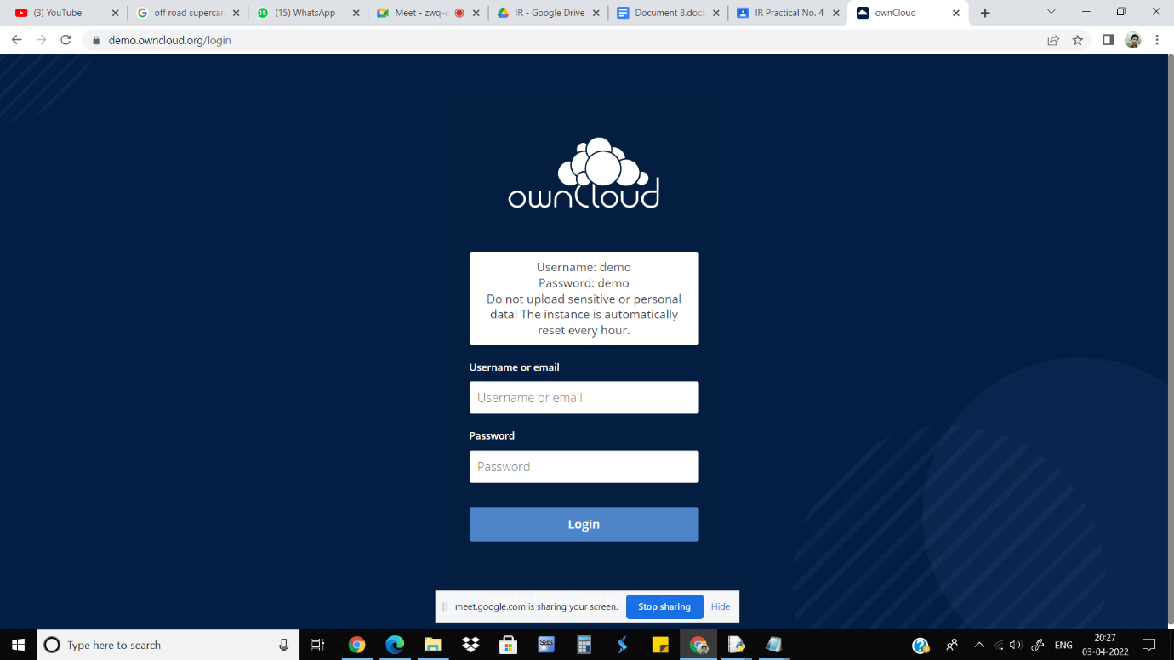

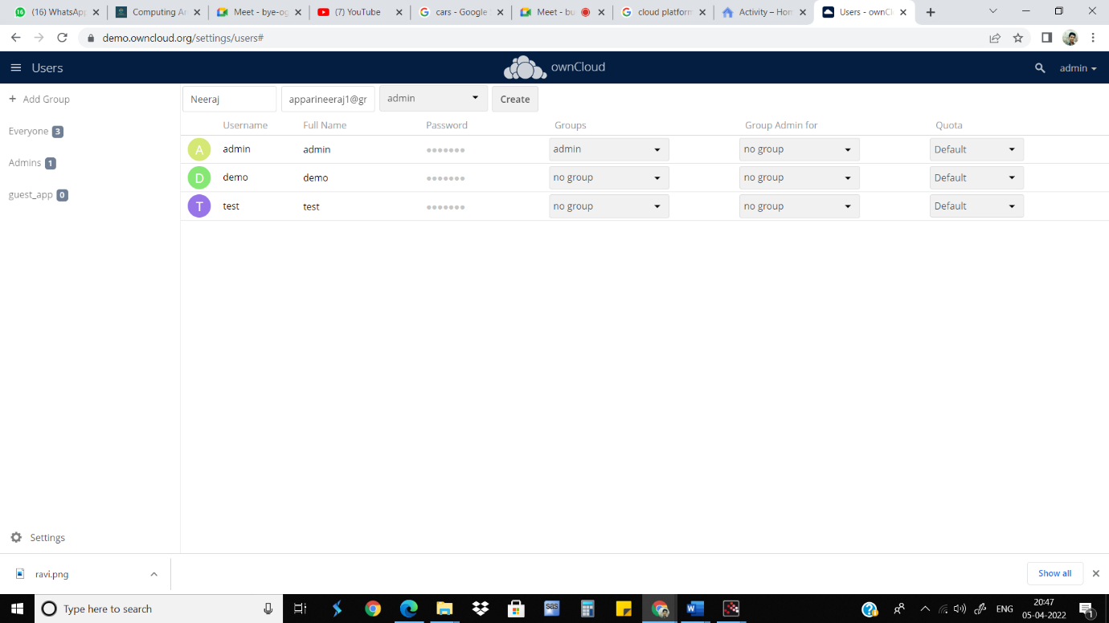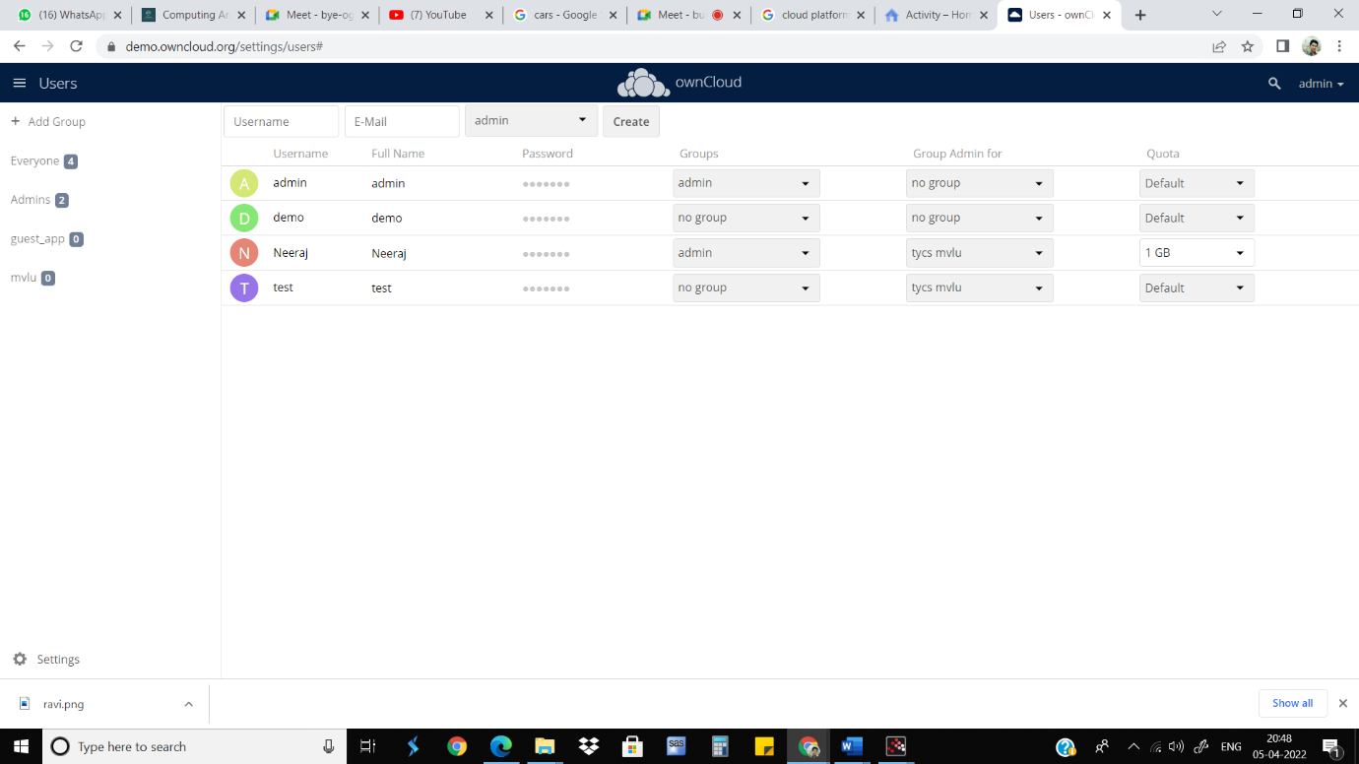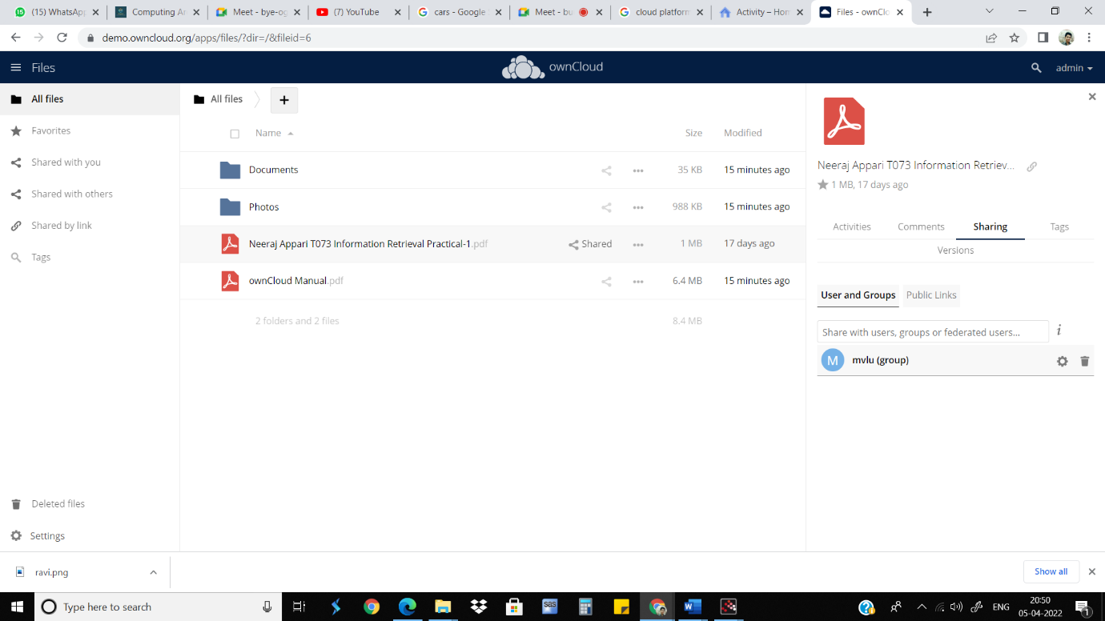

**Conclusion:**

We have studied how to use ownCloud for ensuring identity management of

the users. We can create multiple groups and provide privileges to view or

modify data as per defined permissions. It also enables simplified look and

feel to be used by anyone.

**Cloud Computing Practical - 6**

**Aim**: To Study Cloud Security management

**Objectives:** From this experiment, the student will be able,

* To understand the security features of Cloud.
* To learn the technique of application security management and its

complexity.

* To understand the importance of cloud security management from application

point of view.

**Outcomes**: The learner will be able to

* Student can study and implement single-sign-on.
* To use current techniques, skills, and tools necessary for computing practice.
* To match the industry requirements in the domains of Database management,

Programming and Networking with the required management skills.

**Hardware / Software Required:** Ubuntu operating system, Virtual machine,

WAMP/XAMPP server, Any tool or technology can be used for implementation of web

application e.g., JAVA, PHP, etc.

**Theory:**

Cloud computing security is the set of control-based technologies and

policies designed to adhere to regulatory compliance rules and protect

information, data applications and infrastructure associated with cloud

computing use. Because of the cloud's very nature as a shared resource,

identity management, privacy and access control are of particular concern.

With more organizations using cloud computing and associated cloud

providers for data operations, proper security in these and other potentially

vulnerable areas have become a priority for organizations contracting with a

cloud computing provider.

Cloud computing security processes should address the security controls the

cloud provider will incorporate to maintain the customer's data security,

privacy and compliance with necessary regulations. The processes will also

likely include a business continuity and data backup plan in the case of a

cloud security breach.

**Physical security**

Cloud service providers physically secure the IT hardware (servers, routers,

cables etc.) against unauthorized access, interference, theft, fires, floods etc.

and ensure that essential supplies (such as electricity) are sufficiently robust

to minimize the possibility of disruption. This is normally achieved by

serving cloud applications from 'world-class' (i.e. professionally specified,

designed, constructed, managed, monitored and maintained) data centers.

**Personnel security.**

Various information security concerns relating to the IT and other

professionals associated with cloud services are typically handled through

pre-, para- and post-employment activities such as security screening

potential recruits, security awareness and training programs, proactive

security monitoring and supervision, disciplinary procedures and contractual

obligations embedded in employment contracts, service level agreements,

codes of conduct, policies etc.

**Application security**

Cloud providers ensure that applications available as a service via the cloud

(SaaS) are secure by specifying, designing, implementing, testing and

maintaining appropriate application security measures in the production

environment. Note that - as with any commercial software - the controls they

implement may not necessarily fully mitigate all the risks they have

identified, and that they may not necessarily have identified all the risks that

are of concern to customers. Consequently, customers may also need to

assure themselves that cloud applications are adequately secured for their

specific purposes, including their compliance obligations.

**Procedure:**

1. Visit https://auth0.com
2. Create a new account
3. Select ‘Company’ Account type, fill company name and company size.
4. tick the advanced settings option.
5. Enter tenant domain name. Ex. ‘<your name><current year>’
6. select region as ‘USA’ & click on create account
7. Navigate to ’Security > Multi-factor Auth’
8. click on the ‘Phone Message’ section and enable it.
9. Go back and enable the ‘One-Time Password’ option.
10. Now, Navigate to ’Security > Attack Protection’ and enable ‘Enforce CAPTCHA’ by selecting the 'Always’ option and save it.

**Result:**

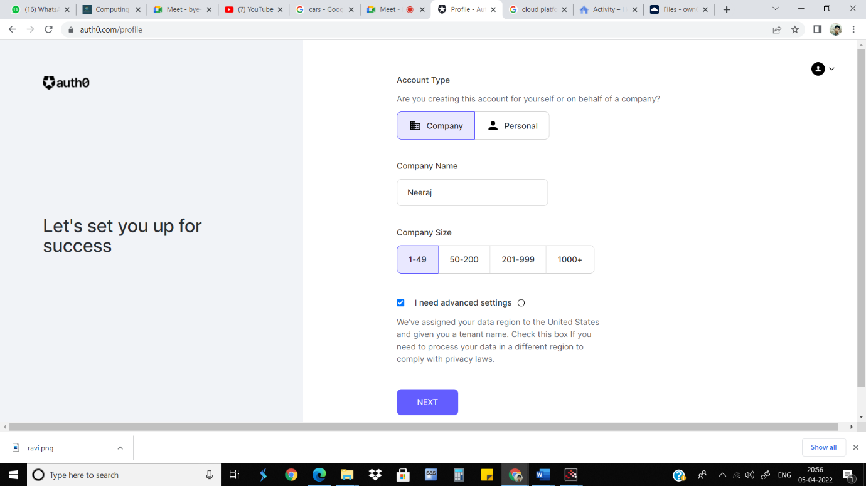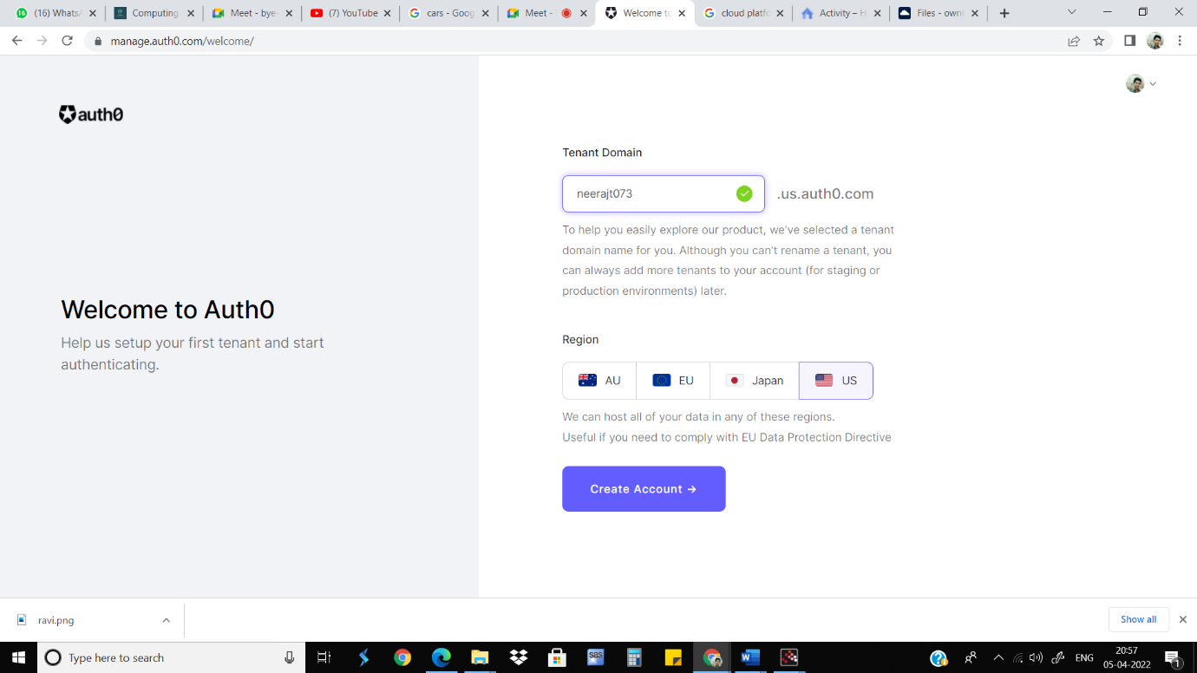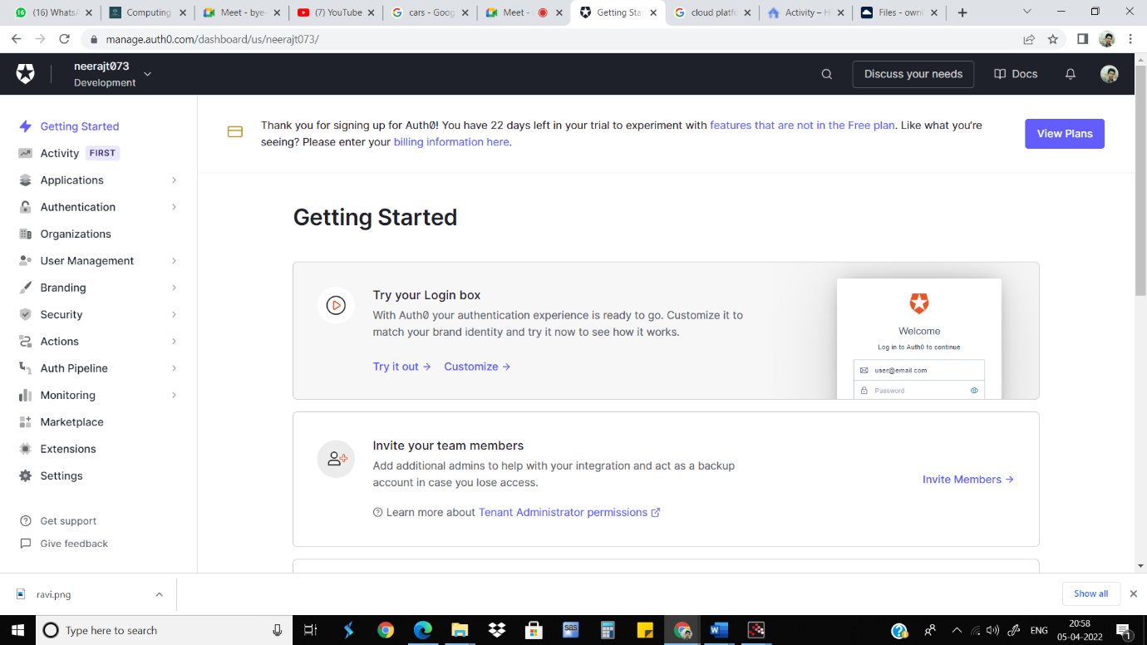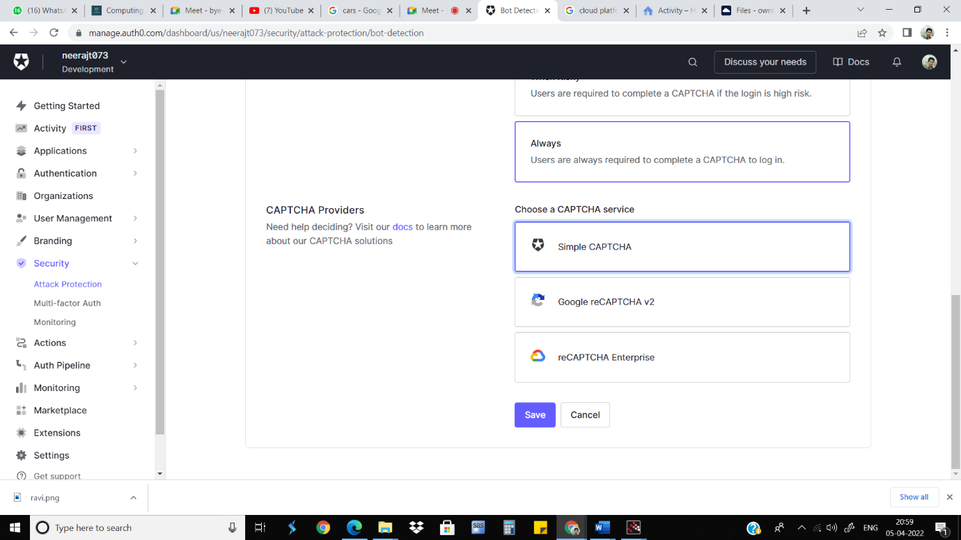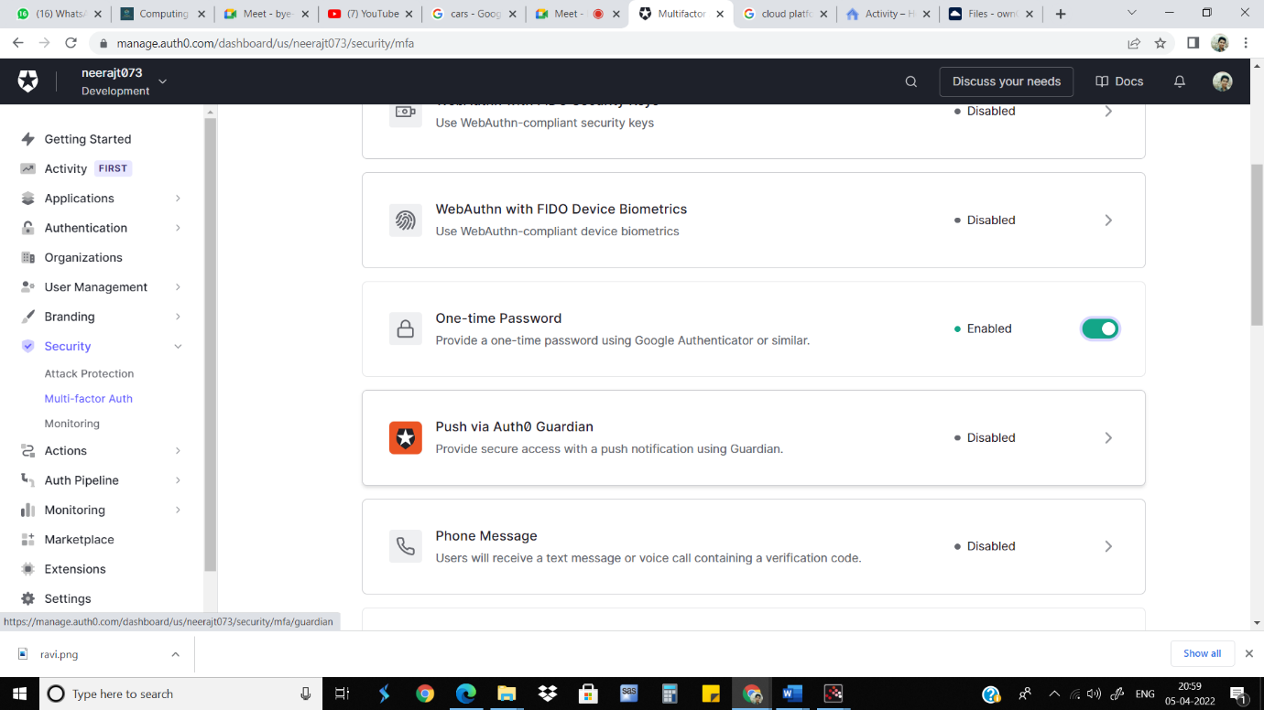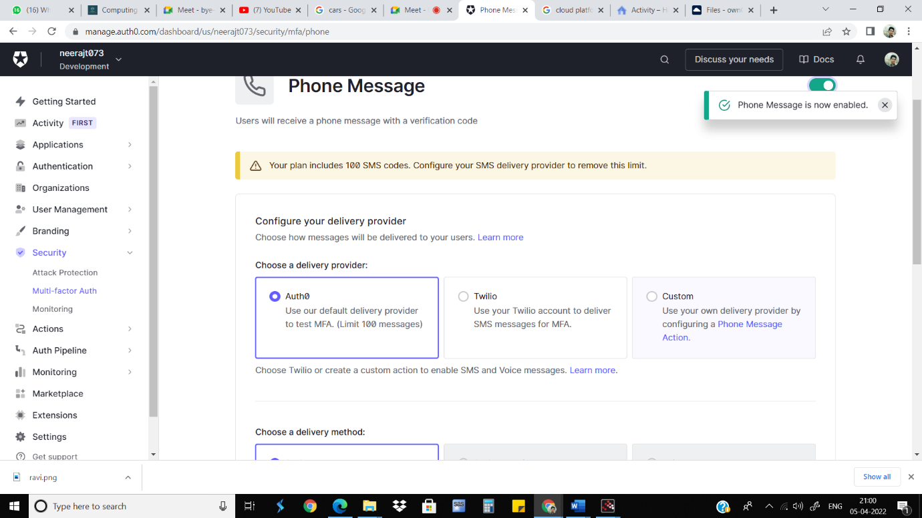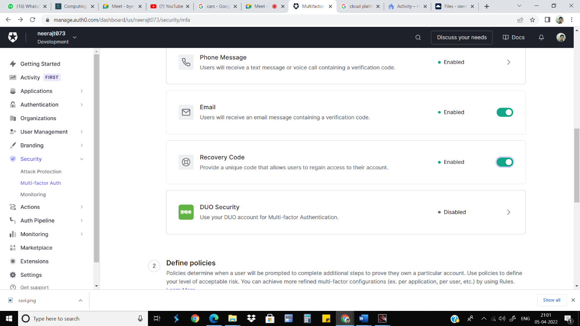

**Conclusion:**

We have studied how to secure the cloud and its data. Amazon EWS provides the

best security with its extended facilities and services like MFA device. It also gives

you the ability to add your own permissions and policies for securing data more

encrypted.

**Cloud Computing Practical - 7**

**Aim**: Write a program for web feed

**RSS** - Really Simple Syndication

**Concept**: Web feed and RSS

**Objective**: This lab is to understand the concept of form and control validation

**Scope**: Write a program for web feed

**Technology**: XML / PHP, HTML

**Theory:**

RSS technology is used by millions of users around the world to get the latest

information from their favorite websites. RSS (RDF Site Summary or Really Simple Syndication) is a web feed that allows users and applications to access updates to websites in a standardized, computer-readable format.

Fundamentally, RSS is simply an XML text file. It's created by a website publisher and contains a running list of articles or other content published by the site, with the newest entry always at the top of the list. Each entry contains details like the article's title, description, and link to the content. [RSS feeds](https://www.businessinsider.com/category/rss-feed) are published and updated in real time, so if you subscribe to a site's RSS feed, you'll always have access to the newest published content. That can be handy for news sites and podcasts that are frequently updated.

**Procedure:**

1. Visit https://gadgets360.com
2. Click on the ‘RSS’ list item in the footer section.
3. Select a random feed out of the given. Ex. ‘Opinion’.
4. Copy the xml code.
5. Create a new directory named ‘RSS’ in the 'XAMPP/htdocs’ folder and create a new xml file and paste the copied xml code. Ex. ‘itvoyage.xml’
6. Start the ‘Apache' server from XAMPP.
7. Open the served xml file in chrome. Ex. ‘http://localhost/RSS/itvoyage.xml'
8. Go to the Chrome Store and search for the Extension 'RSS Subscription Extension’.
9. Add the extension to chrome.
10. Now refresh the page opened on step 7.
11. You will get feed previews.

**Result:**

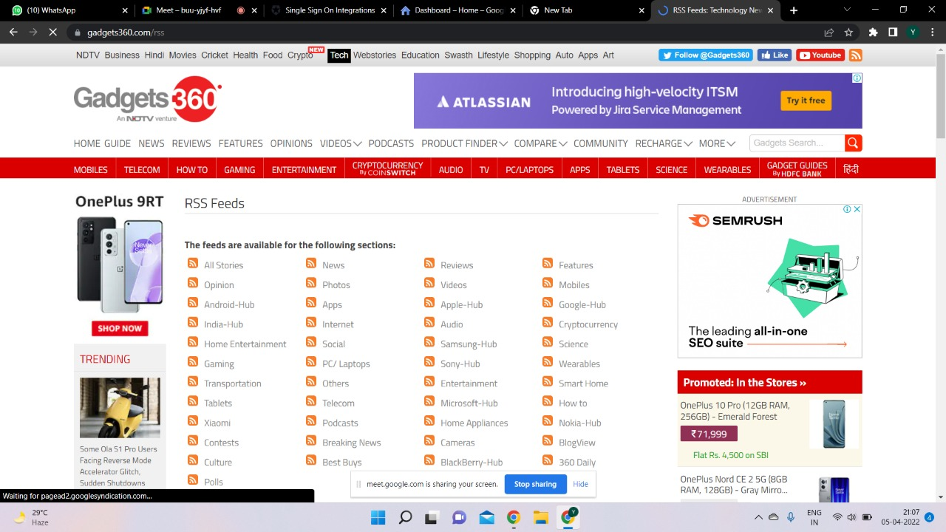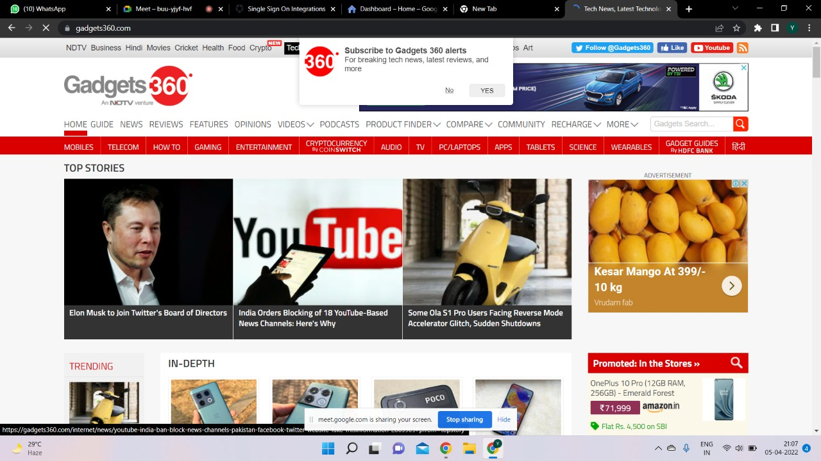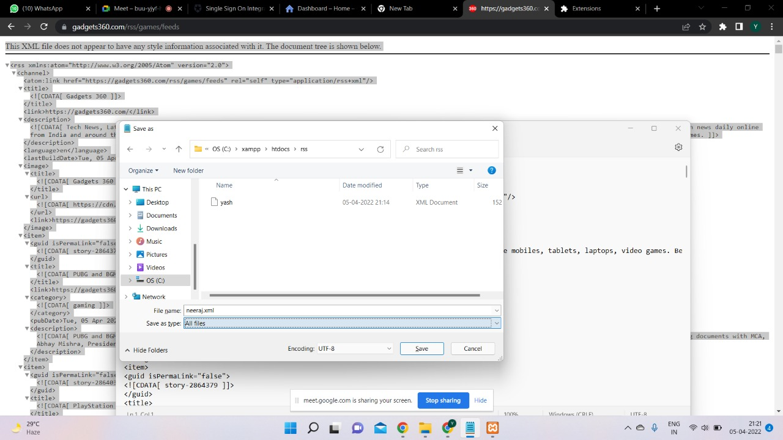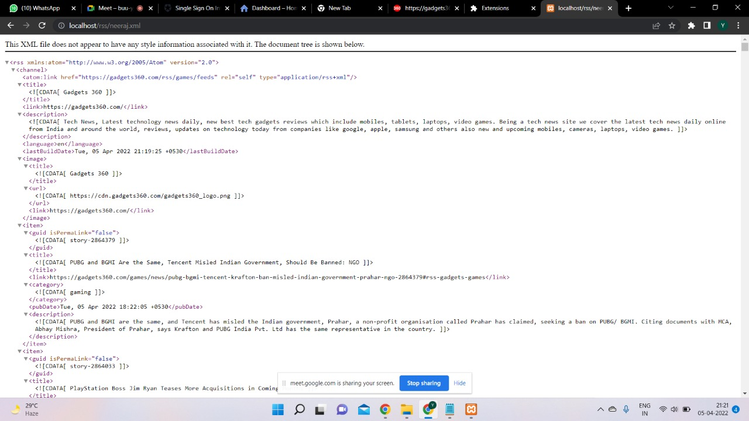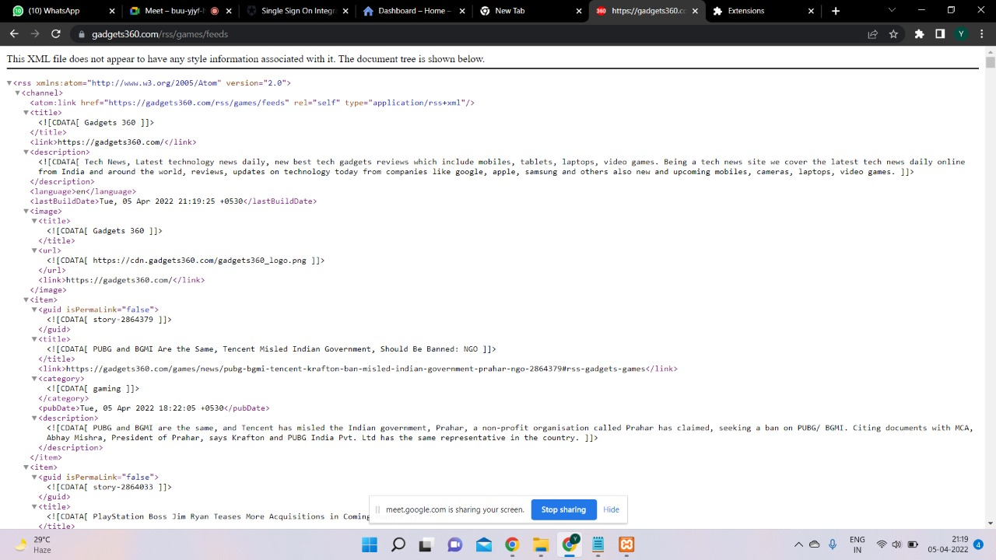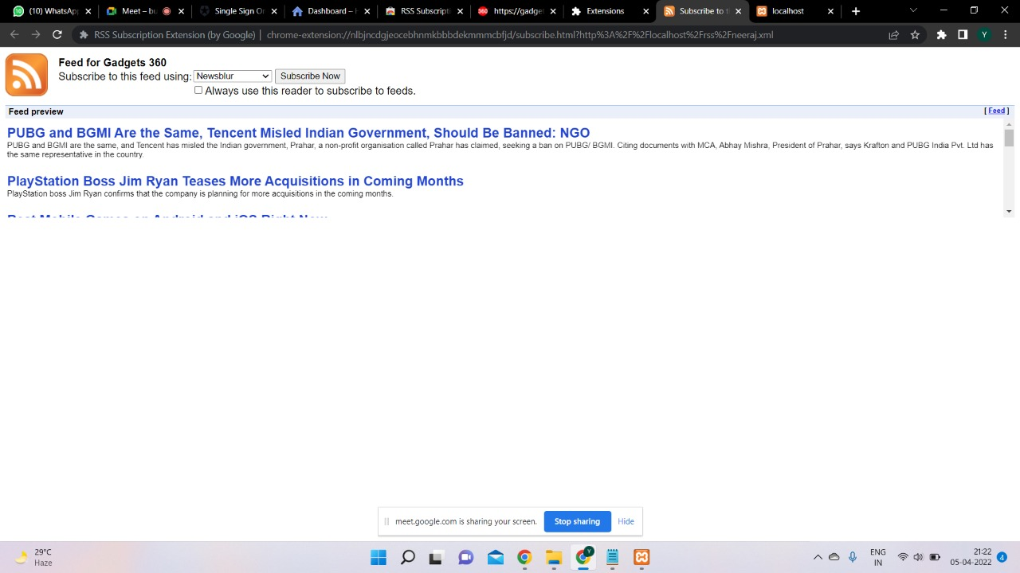

**Conclusion:**

RSS web feed can be used to open any xml feed webpage without having to see the code and direct content.

**Cloud Computing Practical - 8**

**Aim**: Study and implementation of Single-Sign-On

**Concept**: Single Sign On (SSO),openID

**Objective**: is to understand the concept of access control in cloud and single sing on

(SSO), Use SSO and advantages of it, and also students should able to

implementation of it

**Scope**: installing and using auth0

**Technology**: auth0

**Theory:**

Single sign-on (SSO) is a technology which combines several different application login screens into one. With SSO, a user only has to enter their login credentials (username, password, etc.) one time on a single page to access all of their [SaaS](https://www.cloudflare.com/learning/cloud/what-is-saas/) applications.

SSO is often used in a business context, when user applications are assigned and managed by an internal IT team. Remote workers who use SaaS applications also benefit from using SSO.

SSO is an important aspect of many [identity and access management (IAM)](https://www.cloudflare.com/learning/access-management/what-is-identity-and-access-management/) or [access control](https://www.cloudflare.com/learning/access-management/what-is-access-control/) solutions. User identity verification is crucial for knowing which permissions each user should have. [Cloudflare Zero Trust](https://teams.cloudflare.com/access/) is one example of an access control solution that integrates with SSO solutions for managing users' identities.

**Procedure:**

1. **Visit https://auth0.com**
2. **Create a new account**
3. **Select ‘Company’ Account type, fill company name and company size.**
4. **tick the advanced settings option.**
5. **Enter tenant domain name. Ex. ‘<your name><current year>’**
6. **select region as ‘USA’ & click on create account**
7. **Navigate to ‘Applications > SSO Integrations’ on the side navigation bar.**
8. **Click on Create 'New SSO Integration’**
9. **select the ‘Dropbox integration’ and click on continue**
10. **Save the integration.**
11. **Now again perform step 7 and you will find a new integration created.**
12. **Navigate to ’Security > Multi-factor Auth’**
13. **click on ‘Phone Message’ section**

**Result:**

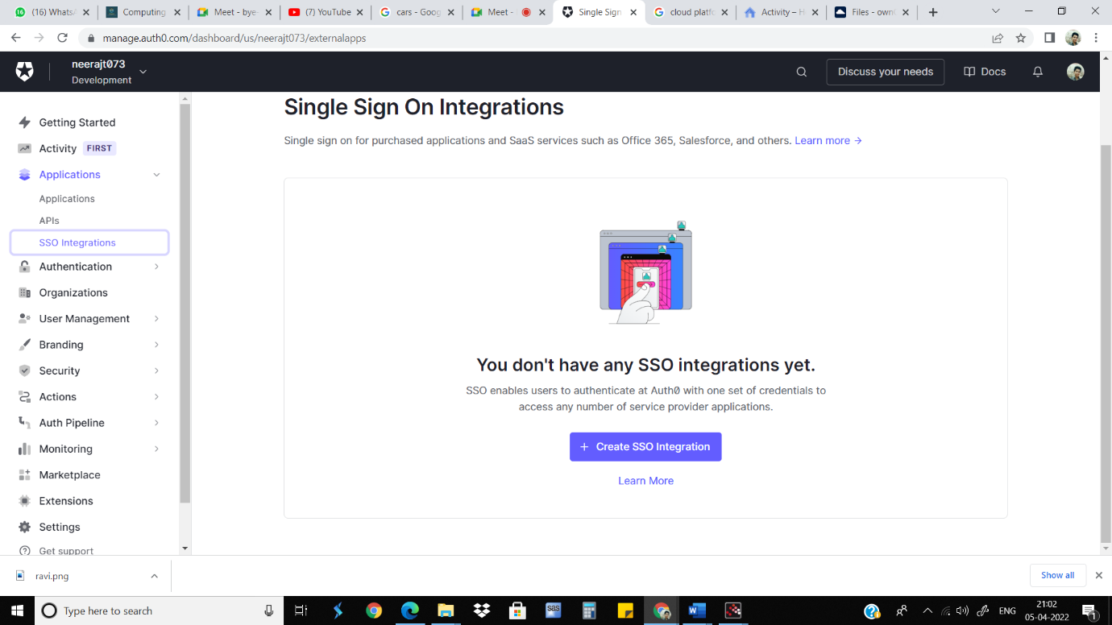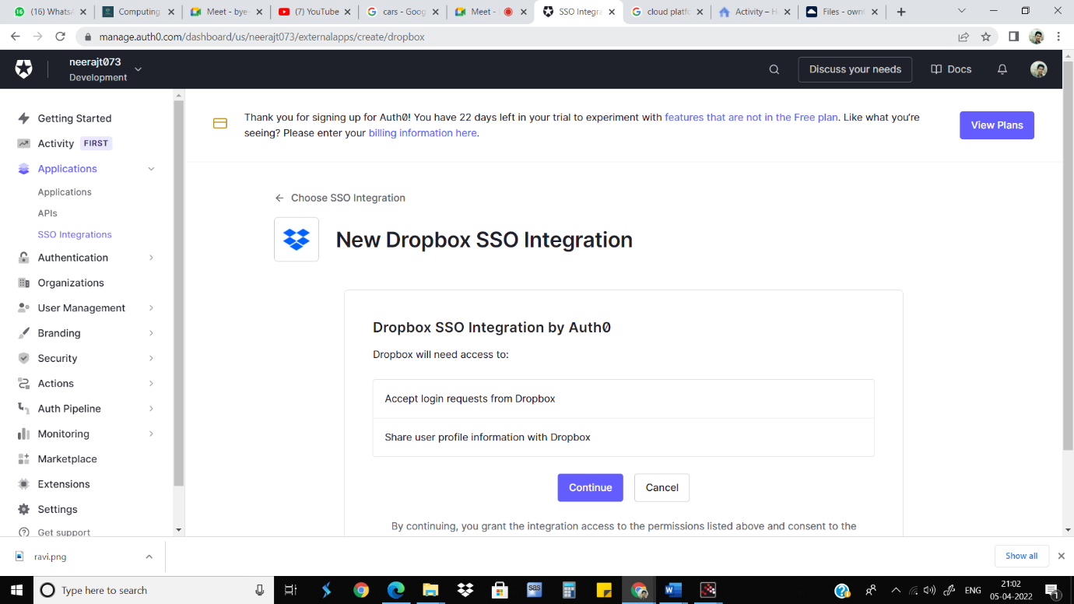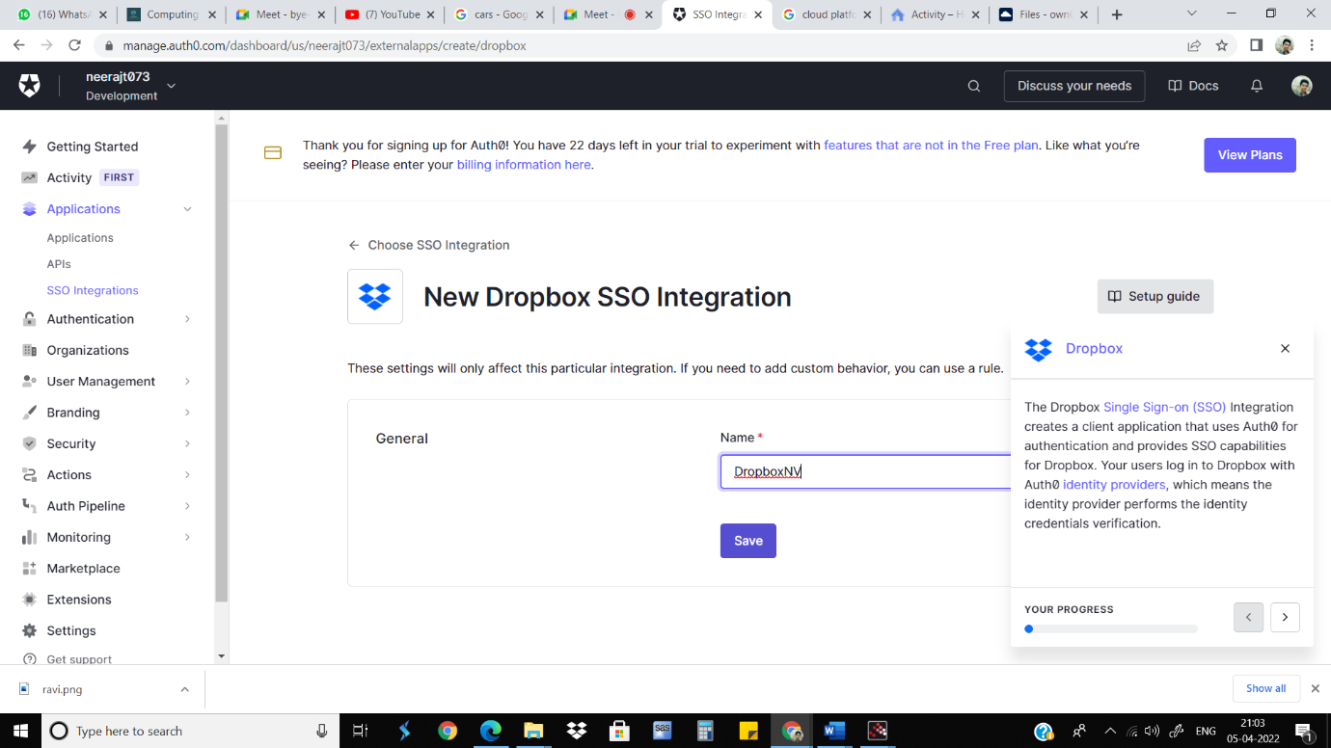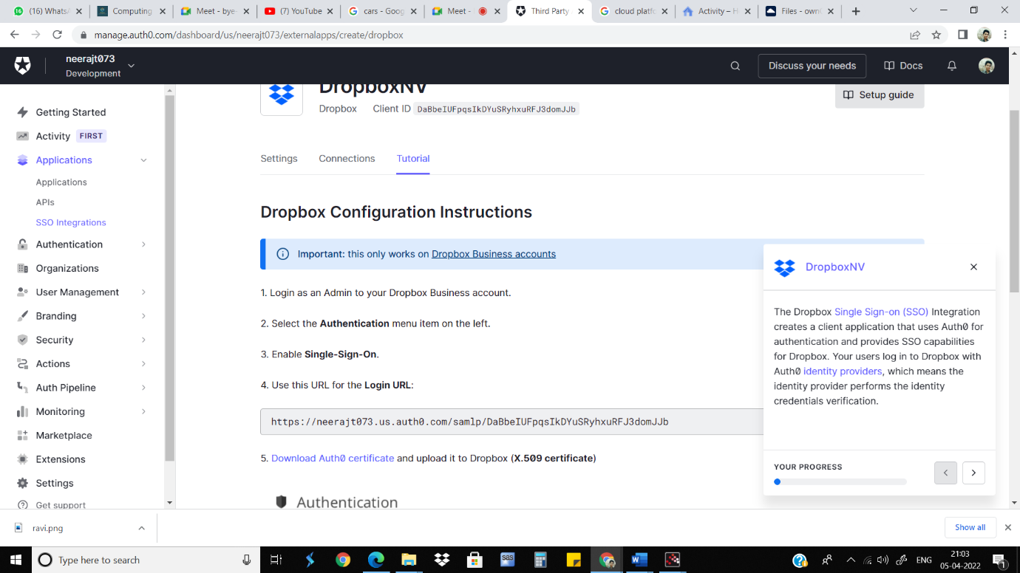

**Conclusion:**

Single Sign-On is all about preventing unneeded user interaction while keeping security to the highest level necessary. There doesn't have to be a trade-off between security and usability: If done properly, SSO improves both.

**Cloud Computing Practical - 9**

**Aim**: User Management in Cloud.

**Concept**: Administrative features of Cloud Management ,User Management

**Objective**: is to understand how to create, manage user and group of users accounts.

**Scope**: Installing and using Administrative features of ownCloud

**Technology**: ownCloud

**Theory:**

ownCloud is a suite of client–server software for creating and using file hosting services. ownCloud functionally has similarities to the widely used Dropbox. The primary functional difference between ownCloud and Dropbox is that ownCloud is primarily server software.

ownCloud supports extensions that allow it to work like [Google Drive](https://en.wikipedia.org/wiki/Google_Drive), with online office suite document editing, calendar and contact synchronization, and more. Its openness avoids enforced [quotas](https://en.wikipedia.org/wiki/Disk_quota) on storage space or the number of connected clients, instead of having hard limits (for example on storage space or number of users) limits are determined by the physical capabilities of the server.

**Procedure:**

1. Visit https://demo.owncloud.org
2. Login using the admin credentials. (admin/admin)
3. Open the personal settings menu on the right corner and Go to ‘Users’ page.
4. Add a new user ’<your name>’ and create a new group named ’tycs’.
5. set a new password for the newly created user.
6. also select the group for the user.
7. Go to settings and click on sharing menu item.
8. check all options for sharing and exclude the admin group from sharing.
9. logout of the admin account and again login using the new user’s account.
10. Go to the files section and add a new file and share it

**Result:**





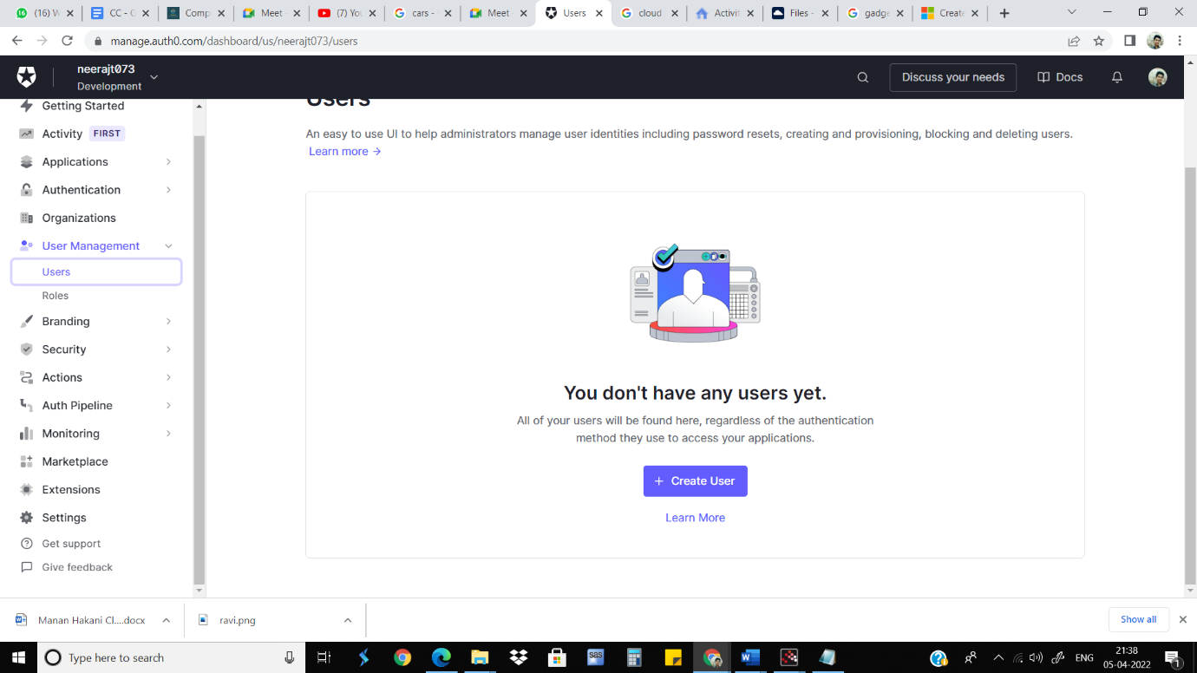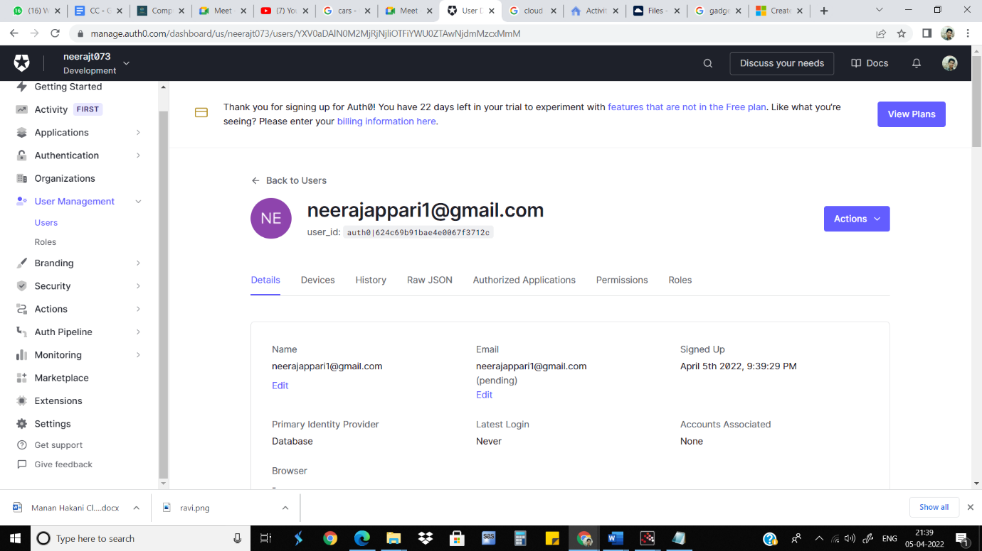

**Conclusion:**

ownCloud is open by nature and designed to integrate with existing infrastructure, management and security tools. A comprehensive set of APIs and native integrations enable anytime, anywhere access to all your data, wherever it resides.

**Cloud Computing Practical - 10**

**Aim**: Case study on Amazon EC2/Microsoft Azure/Google Cloud Platform

**Microsoft Azure:**

[Azure is a cloud computing platform](https://www.simplilearn.com/azure-cloud-services-and-its-importance-article?source=frs_author_page) and an online portal that allows you to access and manage cloud services and resources provided by Microsoft. These services and resources include storing your data and transforming it, depending on your requirements. To get access to these resources and services, all you need to have is an active internet connection and the ability to connect to the Azure portal.

Azure provides more than 200 services, are divided into 18 categories. These categories include computing, networking, storage, [IoT](https://www.simplilearn.com/what-is-iot-how-and-why-it-matters-article), migration, mobile, analytics, containers, [artificial intelligence](https://www.simplilearn.com/tutorials/artificial-intelligence-tutorial/what-is-artificial-intelligence), and other machine learning, integration, management tools, developer tools, security, databases, DevOps, media identity, and web services. Let’s take a look at some of the major Azure services by category:

**Compute Services**

* **Virtual Machine**  
  This service enables you to create a virtual machine in Windows, Linux or any other configuration in seconds.
* **Cloud Service**  
  This service lets you create scalable applications within the cloud. Once the application is deployed, everything, including provisioning, load balancing, and health monitoring, is taken care of by Azure.
* **Service Fabric**  
  With service fabric, the process of developing a microservice is immensely simplified. Microservice is an application that contains other bundled smaller applications.
* **Functions**  
  With functions, you can create applications in any programming language. The best part about this service is that you need not worry about hardware requirements while developing applications because Azure takes care of that. All you need to do is provide the code.

**Azure and the services it provides:**

* Application development: You can create any web application in Azure.
* Testing: After developing an application successfully on the platform, you can test it.
* Application hosting: Once the testing is done, Azure can help you host the application.
* Create virtual machines: You can create virtual machines in any configuration you want with the help of Azure.
* Integrate and sync features: Azure lets you integrate and sync virtual devices and directories